Press release

Pasewalk, February 25th, 2016

Now available with Rotax 912 iS Sport and first class avionics

Premiere for the REMOS GXiS at AERO
German aircraft manufacturer REMOS will present the next generation of its high-wing composite aircraft REMOS GX at AERO. Europe’s most important General Aviation exhibition will take place in Friedrichshafen from April 20th to 23rd, 2016. The redesigned cowling gives a foretaste of what is to be found underneath – the Rotax 912 iS Sport with electronic fuel injection. The new model named REMOS GXiS also offers state-of-the-art avionics by Dynon and Garmin. With this new version, REMOS is heading towards the European LSA with EASA certification.
The REMOS GXiS is a milestone in the development of the aircraft, which is manufactured in Pasewalk, Mecklenburg-Western Pomerania, Germany. The reliable and well-known airframe remains the same, while the engineers completely reinvented the technical basis.
The most significant technical innovation of the GXiS is the integration of the Rotax 912 iS Sport. Thanks to its electronic fuel injection, this engine is more efficient and has more torque than the equally strong carburetor version (74 kW/100 hp). Potential issues like carburetor icing are a thing of the past. Paired with the hydraulically operated constant speed propeller from the German-based manufacturer MT-Propeller, excellent flight performance is guaranteed.
At first glance, one may see the new air intake in the redesigned cowling of the GXiS. This is just one part of the completely optimized cooling system. There are also many invisible modifications on the fuel system and on the electric system on board. In fact, the entire firewall-forward section of the aircraft has been redesigned. This was necessary to implement the Rotax 912 iS Sport.
The result of this development is an extraordinary user-friendly and safe aircraft. For instance, the REMOS engineers made the start-up procedure as easy as it is in your car. Almost all system checks, for which the pilot had to take care before, are done automatically now.
From a pilot’s point of view, the heart of the aircraft is the new avionics suite. Each side of the panel features a touch sensitive 10-inch-screen combined EFIS/EMS Dynon SV-D1000T/B. The center stack is dominated by the Garmin GTN 750, an all in one WAAS GPS/NAV/COM navigation system and control panel for radio, audio panel, transponder and autopilot.
Further enhancing safety, the REMOS GXiS comes with the collision avoidance system TRX-1500 by Air Avionics. It receives ADS-B-signals, deals with FLARM and shows the surrounding traffic on the moving map. The transponder installed in the GXiS sends ADS-B-signals itself. Like all REMOS aircraft, the GXiS is equipped with a ballistic parachute made by the US-manufacturer BRS.
With this equipment on board, the GXiS marks the new standard for the upcoming European Light Sport Aircraft with 600 kg (1320 lbs) MTOW. The aircraft shown at AERO will also be used for remaining flight-testing required for EASA certification.
The new REMOS GXiS will also be offered as an ultralight aircraft. Customers may choose between several more compact avionic options. The standard version will come with the well-proven fixed-pitch three-blade propeller by Neuform.
REMOS will also bring the ultralight GXNXT driven by the conventional Rotax 912 S to the exhibition at Lake Constance. This aircraft has been the top model so far and will remain the first choice for ultralight pilots in the future.
From April 20th to 23rd, AERO is open to the public in Friedrichshafen. The REMOS team is looking forward to meeting you in hall B3, booth 207.

All images are free for publication with copyright note „REMOS AG“.

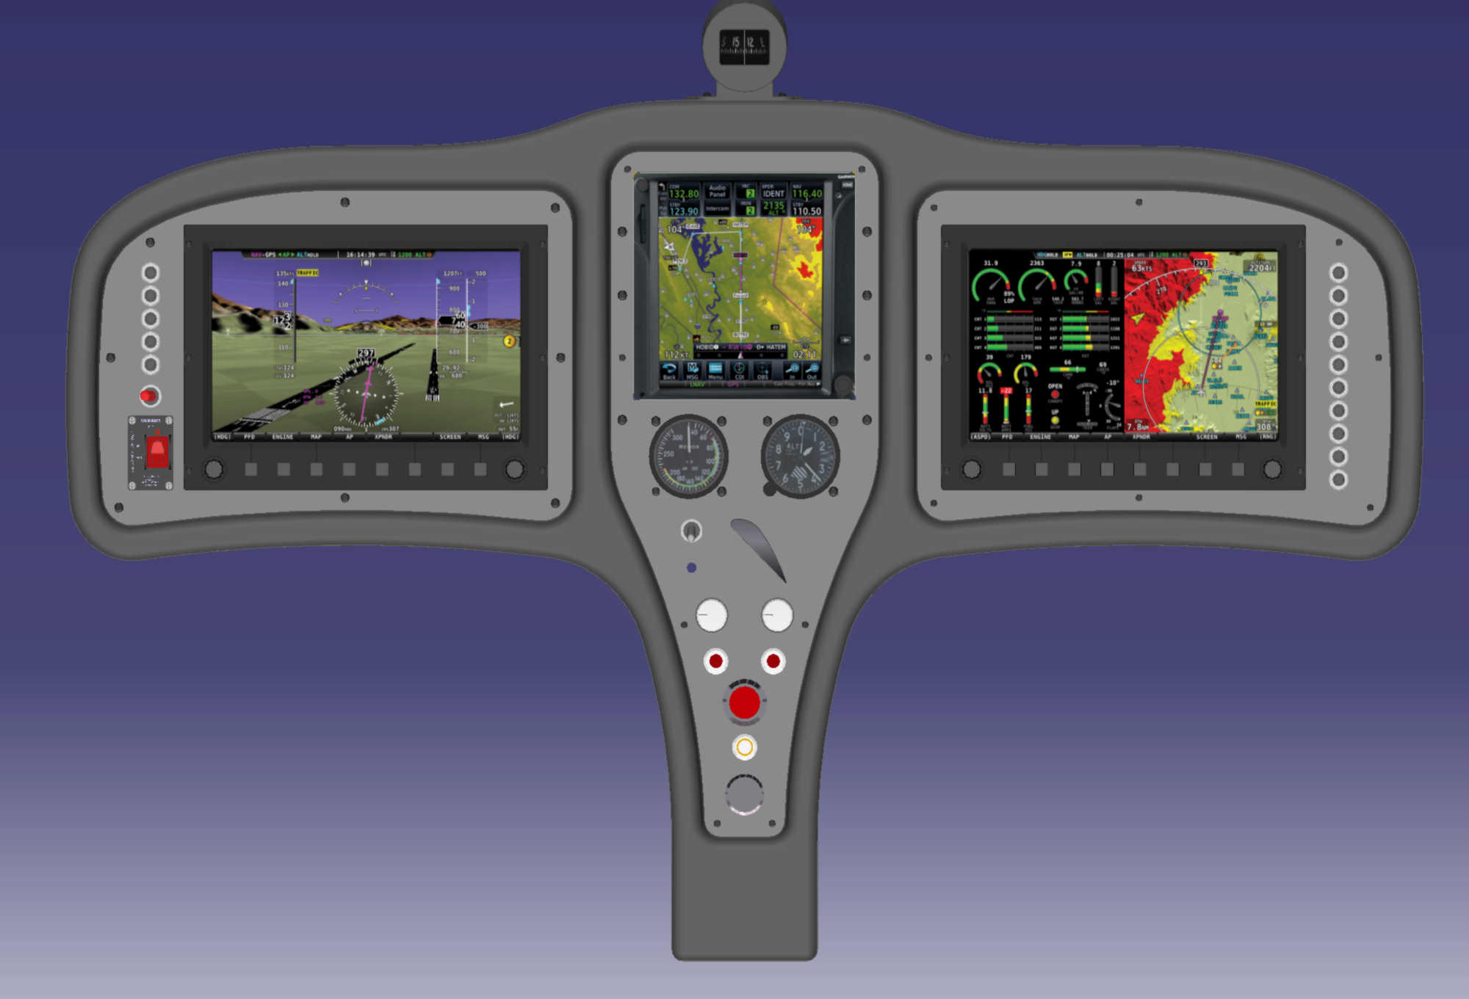
The avionics suite contains instruments from Dynon, Garmin and Air Avionics: With this extensive equipment, the REMOS GXiS is going to be certified as a LSA in Europe.

Well-known design with a new face: The REMOS GXiS is powered by the Rotax 912 iS Sport and offers a high-end avionics suite. This aircraft is the series compliant prototype for the upcoming EASA certified LSA.

The ultralight REMOS GXNXT will also be shown at AERO Friedrichshafen in April.

Press contacts:
REMOS AG
Franzfelde 31
17309 Pasewalk
Germany
Sales: Jürgen Rehländer
juergen.rehlaender@remos.com
mobile: +49 170 3468616
Public Relations & Marketing: Patrick Holland-Moritz
patrick.holland-moritz@remos.com
mobile: +49 151 46533333

